**VI XỬ LÝ – VI ĐIỀU KHIỂN**

**Lớp: L03**

**Họ và tên:** Nguyễn Đình Đạt

**Mssv:** 1811869

**Exercise 1:**

Schematic:

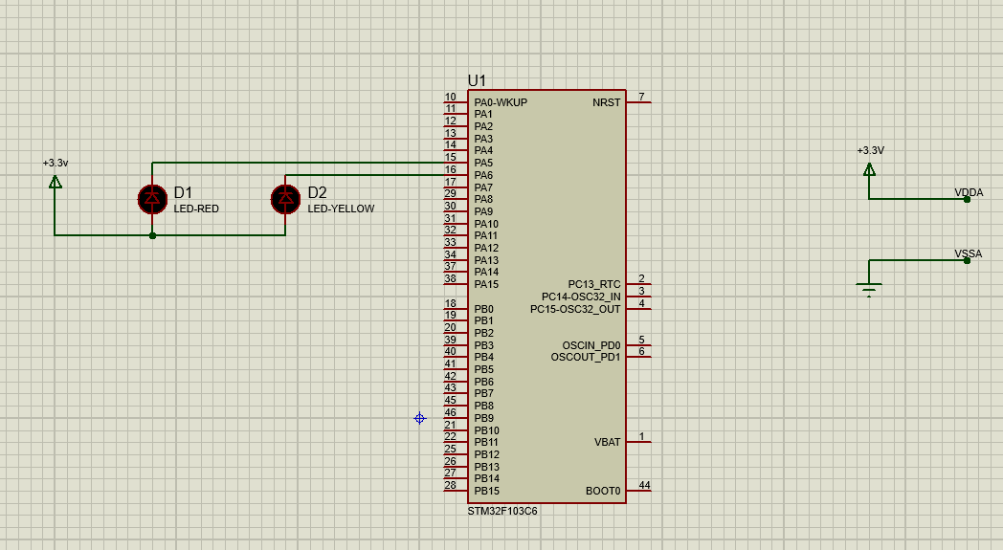

[Figure 1: Schematic transitions for 2 LEDs](https://github.com/ngddat2706/Vxl_Vdk_lab/blob/d6751fb38d8cd0a7b837b4fd31a23df2c83ca8ee/STM32.pdsprj)

The source code in the infinite loop while:

**while** (1)

{

/* USER CODE END WHILE */

HAL_GPIO_TogglePin(GPIOA, GPIO_PIN_6); // turn off led yellow

HAL_Delay(1000);

HAL_GPIO_TogglePin(GPIOA, GPIO_PIN_5 | GPIO_PIN_6); // turn off led red and turn on led yellow

HAL_Delay(1000);

HAL_GPIO_TogglePin(GPIOA, GPIO_PIN_5); // turn on led red

/* USER CODE BEGIN 3 */

}

**Exercise 2:**

Schematic:

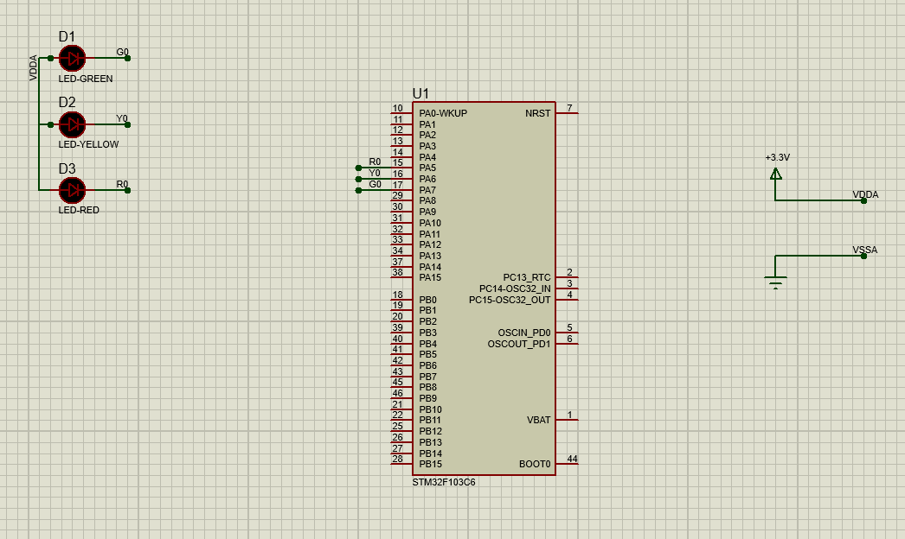

[Figure 2: Schematic for a traffic light](https://github.com/ngddat2706/Vxl_Vdk_lab/blob/d6751fb38d8cd0a7b837b4fd31a23df2c83ca8ee/exercise2.pdsprj)

The source code in the infinite loop while:

**while** (1)

{

/* USER CODE END WHILE */

// turn off led red and led yellow

HAL_GPIO_TogglePin(GPIOA, GPIO_PIN_5|GPIO_PIN_6);

HAL_Delay(3000);

// turn off led green, turn on led yellow

HAL_GPIO_TogglePin(GPIOA, GPIO_PIN_7|GPIO_PIN_6);

HAL_Delay(2000);

// turn on led red, turn off led yellow

HAL_GPIO_TogglePin(GPIOA, GPIO_PIN_5|GPIO_PIN_6);

HAL_Delay(5000);

// turn on led green, led yellow

HAL_GPIO_TogglePin(GPIOA, GPIO_PIN_7|GPIO_PIN_6);

/* USER CODE BEGIN 3 */

}

**Exercise 3:**

Schematic:

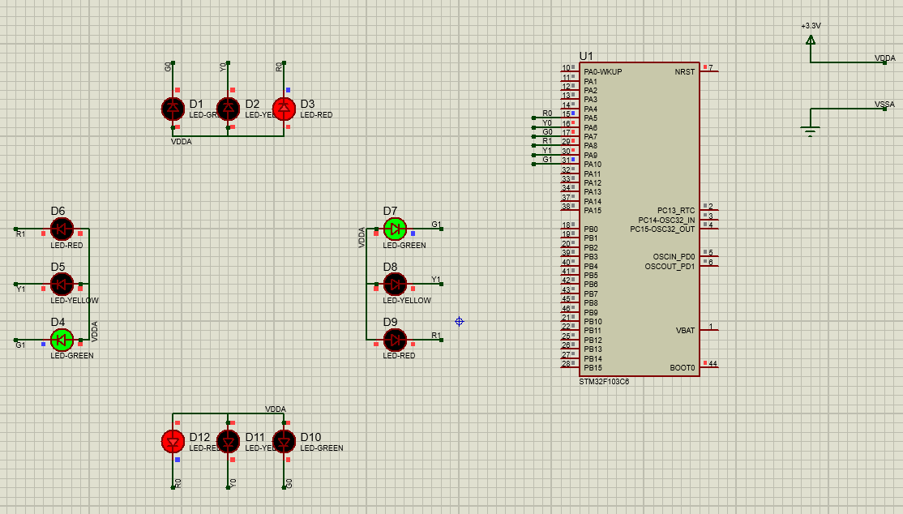

[Figure 3: Schematic for a 4 way traffic light](https://github.com/ngddat2706/Vxl_Vdk_lab/blob/d6751fb38d8cd0a7b837b4fd31a23df2c83ca8ee/exercise3.pdsprj)

The source code in the infinite loop while:

**while** (1)

{

/* USER CODE END WHILE */

HAL_GPIO_TogglePin(GPIOA, GPIO_PIN_9|GPIO_PIN_10); // turn off led yellow_1, turn off led green_1

HAL_GPIO_TogglePin(GPIOA, GPIO_PIN_5|GPIO_PIN_6); // turn off led red_0, turn off led yellow_0

HAL_Delay(3000);

HAL_GPIO_TogglePin(GPIOA, GPIO_PIN_7|GPIO_PIN_6); // turn on led yellow_0, turn off led green_0

HAL_Delay(2000);

HAL_GPIO_TogglePin(GPIOA, GPIO_PIN_8|GPIO_PIN_10); // turn on led green_1, turn off led red_1

HAL_GPIO_TogglePin(GPIOA, GPIO_PIN_5|GPIO_PIN_6); // turn on led red_0, turn off led yellow_0

HAL_Delay(3000);

HAL_GPIO_TogglePin(GPIOA, GPIO_PIN_9|GPIO_PIN_10); // turn on led yellow_1, turn off led green_1

HAL_Delay(2000);

HAL_GPIO_TogglePin(GPIOA, GPIO_PIN_7|GPIO_PIN_6); // turn on led green_0, turn on led yellow_0

HAL_GPIO_TogglePin(GPIOA, GPIO_PIN_8|GPIO_PIN_10); // turn on led red_1, turn on led green_1

/* USER CODE BEGIN 3 */

}

**Exercise 4:**

Schematic:

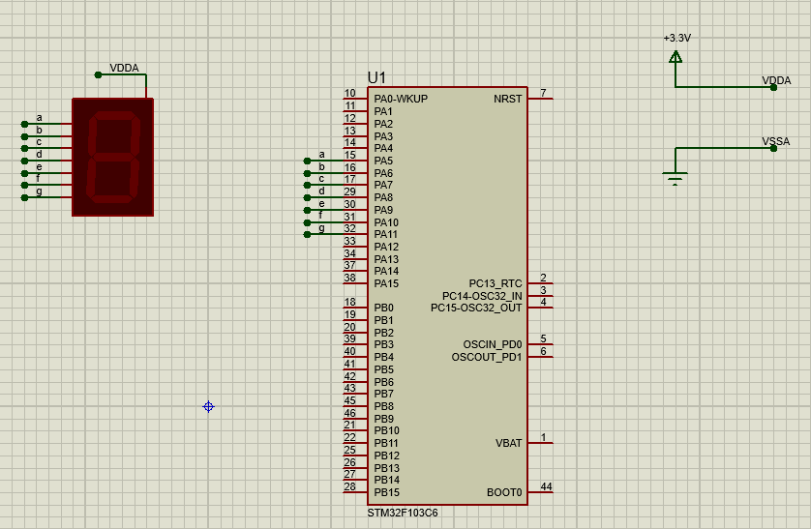

[Figure 4: Schematic transitions for 2 LEDs](https://github.com/ngddat2706/Vxl_Vdk_lab/blob/d6751fb38d8cd0a7b837b4fd31a23df2c83ca8ee/exercise4.pdsprj)

The source code for display7SEG function:

**void** **display7SEG**(**int** counter){

**switch**(counter){

**case** 0:

HAL_GPIO_WritePin(GPIOA, GPIO_PIN_11, 1);

HAL_GPIO_WritePin(GPIOA, GPIO_PIN_5|GPIO_PIN_6|GPIO_PIN_7|GPIO_PIN_8|GPIO_PIN_9|GPIO_PIN_10, 0);

**break**;

**case** 1:

HAL_GPIO_WritePin(GPIOA, GPIO_PIN_5|GPIO_PIN_8|GPIO_PIN_9|GPIO_PIN_10|GPIO_PIN_11, 1);

HAL_GPIO_WritePin(GPIOA, GPIO_PIN_6|GPIO_PIN_7, 0);

**break**;

**case** 2:

HAL_GPIO_WritePin(GPIOA, GPIO_PIN_7|GPIO_PIN_10, 1);

HAL_GPIO_WritePin(GPIOA, GPIO_PIN_5|GPIO_PIN_6|GPIO_PIN_8|GPIO_PIN_8|GPIO_PIN_9|GPIO_PIN_11, 0);

**break**;

**case** 3:

HAL_GPIO_WritePin(GPIOA, GPIO_PIN_9|GPIO_PIN_10, 1);

HAL_GPIO_WritePin(GPIOA, GPIO_PIN_5|GPIO_PIN_6|GPIO_PIN_7|GPIO_PIN_8|GPIO_PIN_11, 0);

**break**;

**case** 4:

HAL_GPIO_WritePin(GPIOA, GPIO_PIN_5|GPIO_PIN_8|GPIO_PIN_9, 1);

HAL_GPIO_WritePin(GPIOA, GPIO_PIN_6|GPIO_PIN_7|GPIO_PIN_10|GPIO_PIN_11, 0);

**break**;

**case** 5:

HAL_GPIO_WritePin(GPIOA, GPIO_PIN_6|GPIO_PIN_9, 1);

HAL_GPIO_WritePin(GPIOA, GPIO_PIN_5|GPIO_PIN_7|GPIO_PIN_8|GPIO_PIN_10|GPIO_PIN_11, 0);

**break**;

**case** 6:

HAL_GPIO_WritePin(GPIOA, GPIO_PIN_6, 1);

HAL_GPIO_WritePin(GPIOA, GPIO_PIN_5|GPIO_PIN_7|GPIO_PIN_8|GPIO_PIN_9|GPIO_PIN_10|GPIO_PIN_11, 0);

**break**;

**case** 7:

HAL_GPIO_WritePin(GPIOA, GPIO_PIN_8|GPIO_PIN_9|GPIO_PIN_10|GPIO_PIN_11, 1);

HAL_GPIO_WritePin(GPIOA, GPIO_PIN_5|GPIO_PIN_6|GPIO_PIN_7, 0);

**break**;

**case** 8:

HAL_GPIO_WritePin(GPIOA, GPIO_PIN_5|GPIO_PIN_6|GPIO_PIN_7|GPIO_PIN_8|GPIO_PIN_9|GPIO_PIN_10|GPIO_PIN_11, 0);

**break**;

**case** 9:

HAL_GPIO_WritePin(GPIOA, GPIO_PIN_9, 1);

HAL_GPIO_WritePin(GPIOA, GPIO_PIN_5|GPIO_PIN_6|GPIO_PIN_7|GPIO_PIN_8|GPIO_PIN_10|GPIO_PIN_11, 0);

**break**;

}

}

**Exercise 5:**

Schematic:

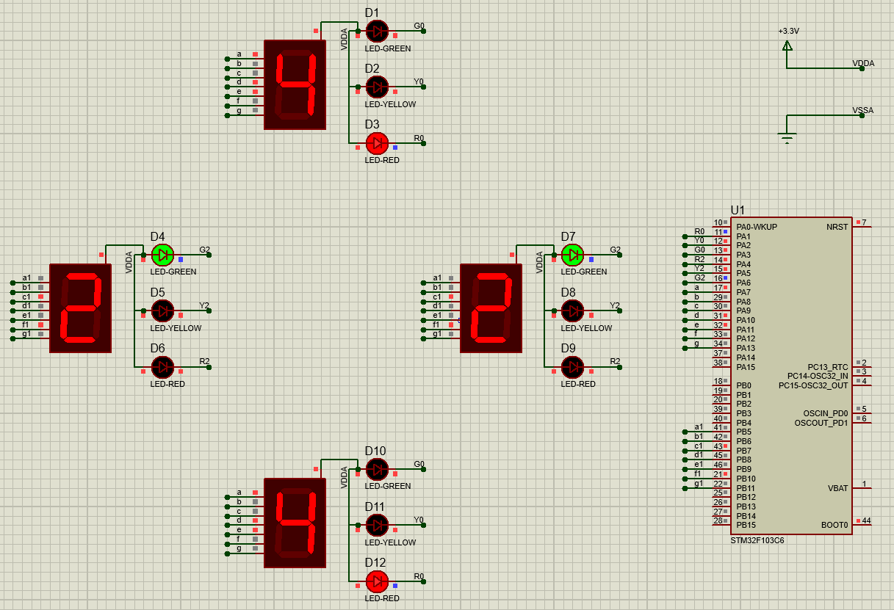

[Figure 5: Integrate the 7SEG-LED to the 4 way traffic light](https://github.com/ngddat2706/Vxl_Vdk_lab/blob/d6751fb38d8cd0a7b837b4fd31a23df2c83ca8ee/exercise5.pdsprj)

The source code to Integrate the 7SEG-LED to the 4 way traffic light

// Display led 7 segment top and bottom

**void** **display7SEG**(**int** counter){

**switch**(counter){

**case** 0:

HAL_GPIO_WritePin(GPIOA, GPIO_PIN_13, 1);

HAL_GPIO_WritePin(GPIOA, GPIO_PIN_7|GPIO_PIN_8|GPIO_PIN_9|GPIO_PIN_10|GPIO_PIN_11|GPIO_PIN_12, 0);

**break**;

**case** 1:

HAL_GPIO_WritePin(GPIOA, GPIO_PIN_7|GPIO_PIN_10|GPIO_PIN_11|GPIO_PIN_12|GPIO_PIN_13, 1);

HAL_GPIO_WritePin(GPIOA, GPIO_PIN_8|GPIO_PIN_9, 0);

**break**;

**case** 2:

HAL_GPIO_WritePin(GPIOA, GPIO_PIN_9|GPIO_PIN_12, 1);

HAL_GPIO_WritePin(GPIOA, GPIO_PIN_7|GPIO_PIN_8|GPIO_PIN_10|GPIO_PIN_11|GPIO_PIN_13, 0);

**break**;

**case** 3:

HAL_GPIO_WritePin(GPIOA, GPIO_PIN_11|GPIO_PIN_12, 1);

HAL_GPIO_WritePin(GPIOA, GPIO_PIN_7|GPIO_PIN_8|GPIO_PIN_9|GPIO_PIN_10|GPIO_PIN_13, 0);

**break**;

**case** 4:

HAL_GPIO_WritePin(GPIOA, GPIO_PIN_7|GPIO_PIN_10|GPIO_PIN_11, 1);

HAL_GPIO_WritePin(GPIOA, GPIO_PIN_8|GPIO_PIN_9|GPIO_PIN_12|GPIO_PIN_13, 0);

**break**;

**case** 5:

HAL_GPIO_WritePin(GPIOA, GPIO_PIN_8|GPIO_PIN_11, 1);

HAL_GPIO_WritePin(GPIOA, GPIO_PIN_7|GPIO_PIN_9|GPIO_PIN_10|GPIO_PIN_12|GPIO_PIN_13, 0);

**break**;

**case** 6:

HAL_GPIO_WritePin(GPIOA, GPIO_PIN_8, 1);

HAL_GPIO_WritePin(GPIOA, GPIO_PIN_7|GPIO_PIN_9|GPIO_PIN_10|GPIO_PIN_11|GPIO_PIN_12|GPIO_PIN_13, 0);

**break**;

**case** 7:

HAL_GPIO_WritePin(GPIOA, GPIO_PIN_10|GPIO_PIN_11|GPIO_PIN_12|GPIO_PIN_13, 1);

HAL_GPIO_WritePin(GPIOA, GPIO_PIN_7|GPIO_PIN_8|GPIO_PIN_9, 0);

**break**;

**case** 8:

HAL_GPIO_WritePin(GPIOA, GPIO_PIN_7|GPIO_PIN_8|GPIO_PIN_9|GPIO_PIN_10|GPIO_PIN_11|GPIO_PIN_12|GPIO_PIN_13, 0);

**break**;

**case** 9:

HAL_GPIO_WritePin(GPIOA, GPIO_PIN_11, 1);

HAL_GPIO_WritePin(GPIOA, GPIO_PIN_7|GPIO_PIN_8|GPIO_PIN_9|GPIO_PIN_10|GPIO_PIN_12|GPIO_PIN_13, 0);

**break**;

}

}

// Display led 7 segment right and left

**void** **display7SEG_1**(**int** counter){

**switch**(counter){

**case** 0:

HAL_GPIO_WritePin(GPIOB, GPIO_PIN_11, 1);

HAL_GPIO_WritePin(GPIOB, GPIO_PIN_5|GPIO_PIN_6|GPIO_PIN_7|GPIO_PIN_8|GPIO_PIN_9|GPIO_PIN_10, 0);

**break**;

**case** 1:

HAL_GPIO_WritePin(GPIOB, GPIO_PIN_5|GPIO_PIN_8|GPIO_PIN_9|GPIO_PIN_10|GPIO_PIN_11, 1);

HAL_GPIO_WritePin(GPIOB, GPIO_PIN_6|GPIO_PIN_7, 0);

**break**;

**case** 2:

HAL_GPIO_WritePin(GPIOB, GPIO_PIN_7|GPIO_PIN_10, 1);

HAL_GPIO_WritePin(GPIOB, GPIO_PIN_5|GPIO_PIN_6|GPIO_PIN_8|GPIO_PIN_9|GPIO_PIN_11, 0);

**break**;

**case** 3:

HAL_GPIO_WritePin(GPIOB, GPIO_PIN_9|GPIO_PIN_10, 1);

HAL_GPIO_WritePin(GPIOB, GPIO_PIN_5|GPIO_PIN_6|GPIO_PIN_7|GPIO_PIN_8|GPIO_PIN_11, 0);

**break**;

**case** 4:

HAL_GPIO_WritePin(GPIOB, GPIO_PIN_5|GPIO_PIN_8|GPIO_PIN_9, 1);

HAL_GPIO_WritePin(GPIOB, GPIO_PIN_6|GPIO_PIN_7|GPIO_PIN_10|GPIO_PIN_11, 0);

**break**;

**case** 5:

HAL_GPIO_WritePin(GPIOB, GPIO_PIN_6|GPIO_PIN_9, 1);

HAL_GPIO_WritePin(GPIOB, GPIO_PIN_5|GPIO_PIN_7|GPIO_PIN_8|GPIO_PIN_10|GPIO_PIN_11, 0);

**break**;

**case** 6:

HAL_GPIO_WritePin(GPIOB, GPIO_PIN_6, 1);

HAL_GPIO_WritePin(GPIOB, GPIO_PIN_5|GPIO_PIN_7|GPIO_PIN_8|GPIO_PIN_9|GPIO_PIN_10|GPIO_PIN_11, 0);

**break**;

**case** 7:

HAL_GPIO_WritePin(GPIOB, GPIO_PIN_8|GPIO_PIN_9|GPIO_PIN_10|GPIO_PIN_11, 1);

HAL_GPIO_WritePin(GPIOB, GPIO_PIN_5|GPIO_PIN_6|GPIO_PIN_7, 0);

**break**;

**case** 8:

HAL_GPIO_WritePin(GPIOB, GPIO_PIN_5|GPIO_PIN_6|GPIO_PIN_7|GPIO_PIN_8|GPIO_PIN_9|GPIO_PIN_10|GPIO_PIN_11, 0);

**break**;

**case** 9:

HAL_GPIO_WritePin(GPIOB, GPIO_PIN_9, 1);

HAL_GPIO_WritePin(GPIOB, GPIO_PIN_5|GPIO_PIN_6|GPIO_PIN_7|GPIO_PIN_8|GPIO_PIN_10|GPIO_PIN_11, 0);

**break**;

}

}

**int** counter_g = 3;

**int** counter_r = 5;

**int** counter_y = 2;

**int** counter_g1= 3;

**int** counter_r1= 5;

**int** counter_y1= 2;

**while** (1)

{

/* USER CODE END WHILE */

HAL_GPIO_TogglePin(GPIOA, GPIO_PIN_1|GPIO_PIN_2);

HAL_GPIO_TogglePin(GPIOA, GPIO_PIN_5|GPIO_PIN_6);

**while**(counter_g > 0){

display7SEG_1(counter_r1) ;

counter_r1 --;

display7SEG(counter_g);

counter_g --;

HAL_Delay (1000) ;

}

HAL_GPIO_TogglePin(GPIOA, GPIO_PIN_3|GPIO_PIN_2);

**while**(counter_y > 0){

display7SEG_1(counter_r1) ;

counter_r1 --;

display7SEG(counter_y);

counter_y --;

HAL_Delay (1000) ;

}

HAL_GPIO_TogglePin(GPIOA, GPIO_PIN_1|GPIO_PIN_2);

HAL_GPIO_TogglePin(GPIOA, GPIO_PIN_4|GPIO_PIN_6);

**while**(counter_g1 > 0){

display7SEG_1(counter_g1) ;

counter_g1 --;

display7SEG(counter_r);

counter_r --;

HAL_Delay (1000) ;

}

HAL_GPIO_TogglePin(GPIOA, GPIO_PIN_5|GPIO_PIN_6);

**while**(counter_y1 > 0){

display7SEG_1(counter_y1) ;

counter_y1 --;

display7SEG(counter_r);

counter_r --;

HAL_Delay (1000) ;

}

HAL_GPIO_TogglePin(GPIOA, GPIO_PIN_4|GPIO_PIN_6);

HAL_GPIO_TogglePin(GPIOA, GPIO_PIN_3|GPIO_PIN_2);

counter_g = 3;

counter_r = 5;

counter_y = 2;

counter_g1= 3;

counter_r1= 5;

counter_y1= 2;

/* USER CODE BEGIN 3 */

}

**Exercise 6:**

Schematic:

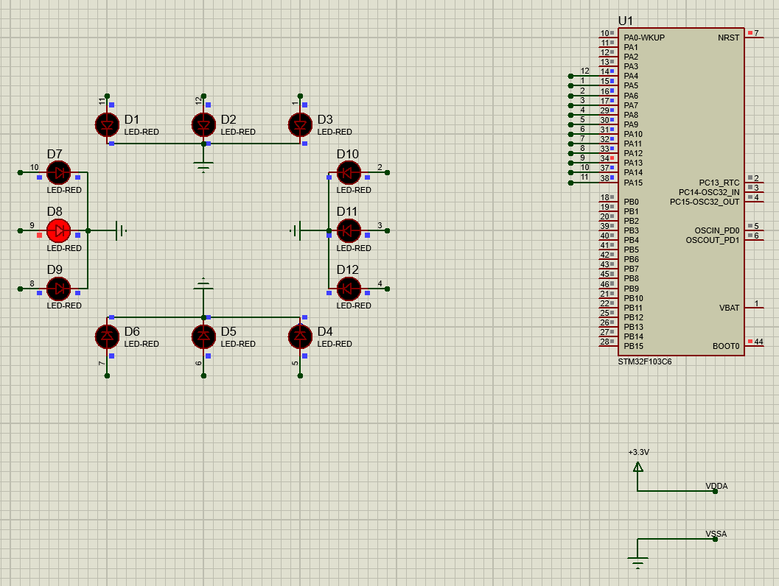

[Figure 6: Schematic transitions for 12 LEDs](https://github.com/ngddat2706/Vxl_Vdk_lab/blob/2b42ab60a00bbb9a0e5eac5a2440277f60d35ceb/exercise6.pdsprj)

The source code in the infinite loop while:

**while** (1)

{

/* USER CODE END WHILE */

HAL_GPIO_TogglePin(GPIOA, GPIO_PIN_4);

HAL_Delay(1000);

HAL_GPIO_TogglePin(GPIOA, GPIO_PIN_4| GPIO_PIN_5);

HAL_Delay(1000);

HAL_GPIO_TogglePin(GPIOA, GPIO_PIN_5| GPIO_PIN_6);

HAL_Delay(1000);

HAL_GPIO_TogglePin(GPIOA, GPIO_PIN_6| GPIO_PIN_7);

HAL_Delay(1000);

HAL_GPIO_TogglePin(GPIOA, GPIO_PIN_7| GPIO_PIN_8);

HAL_Delay(1000);

HAL_GPIO_TogglePin(GPIOA, GPIO_PIN_8| GPIO_PIN_9);

HAL_Delay(1000);

HAL_GPIO_TogglePin(GPIOA, GPIO_PIN_9| GPIO_PIN_10);

HAL_Delay(1000);

HAL_GPIO_TogglePin(GPIOA, GPIO_PIN_10| GPIO_PIN_11);

HAL_Delay(1000);

HAL_GPIO_TogglePin(GPIOA, GPIO_PIN_11| GPIO_PIN_12);

HAL_Delay(1000);

HAL_GPIO_TogglePin(GPIOA, GPIO_PIN_12| GPIO_PIN_13);

HAL_Delay(1000);

HAL_GPIO_TogglePin(GPIOA, GPIO_PIN_13| GPIO_PIN_14);

HAL_Delay(1000);

HAL_GPIO_TogglePin(GPIOA, GPIO_PIN_14| GPIO_PIN_15);

HAL_Delay(1000);

HAL_GPIO_TogglePin(GPIOA, GPIO_PIN_15);

/* USER CODE BEGIN 3 */

}

**Exercise 7:**

Implement a function named **clearAllClock()** to turn off all 12 LEDs. Present the source code of this function:

**void** **clearAllClock**(){

HAL_GPIO_WritePin(GPIOA, GPIO_PIN_4|GPIO_PIN_5| GPIO_PIN_6|

GPIO_PIN_7| GPIO_PIN_8|GPIO_PIN_9| GPIO_PIN_10|GPIO_PIN_11|

GPIO_PIN_12|GPIO_PIN_13| GPIO_PIN_14|GPIO_PIN_15, 0);

}

**Exercise 8:**

Implement a function named **setNumberOnClock(int num)**. The input for this function is from **0 to 11** and an appropriate LED is turn on. Present the source code of this function.

**void** **setNumberOnClock**(**int** num){

**switch**(num){

**case** 0: HAL_GPIO_WritePin(GPIOA, GPIO_PIN_4, 1);

**break**;

**case** 1: HAL_GPIO_WritePin(GPIOA, GPIO_PIN_5, 1);

**break**;

**case** 2: HAL_GPIO_WritePin(GPIOA, GPIO_PIN_6, 1);

**break**;

**case** 3: HAL_GPIO_WritePin(GPIOA, GPIO_PIN_7, 1);

**break**;

**case** 4: HAL_GPIO_WritePin(GPIOA, GPIO_PIN_8, 1);

**break**;

**case** 5: HAL_GPIO_WritePin(GPIOA, GPIO_PIN_9, 1);

**break**;

**case** 6: HAL_GPIO_WritePin(GPIOA, GPIO_PIN_10, 1);

**break**;

**case** 7: HAL_GPIO_WritePin(GPIOA, GPIO_PIN_11, 1);

**break**;

**case** 8: HAL_GPIO_WritePin(GPIOA, GPIO_PIN_12, 1);

**break**;

**case** 9: HAL_GPIO_WritePin(GPIOA, GPIO_PIN_13, 1);

**break**;

**case** 10: HAL_GPIO_WritePin(GPIOA, GPIO_PIN_14, 1);

**break**;

**case** 11: HAL_GPIO_WritePin(GPIOA, GPIO_PIN_15, 1);

**break**;

}

}

**Exercise 9:**

Implement a function named **clearNumberOnClock(int num)**. The input for this function is from **0 to 11** and an appropriate LED is turn off:

**void** **clearNumberOnClock**(**int** num){

**switch**(num){

**case** 0: HAL_GPIO_WritePin(GPIOA, GPIO_PIN_4, 0);

**break**;

**case** 1: HAL_GPIO_WritePin(GPIOA, GPIO_PIN_5, 0);

**break**;

**case** 2: HAL_GPIO_WritePin(GPIOA, GPIO_PIN_6, 0);

**break**;

**case** 3: HAL_GPIO_WritePin(GPIOA, GPIO_PIN_7, 0);

**break**;

**case** 4: HAL_GPIO_WritePin(GPIOA, GPIO_PIN_8, 0);

**break**;

**case** 5: HAL_GPIO_WritePin(GPIOA, GPIO_PIN_9, 0);

**break**;

**case** 6: HAL_GPIO_WritePin(GPIOA, GPIO_PIN_10, 0);

**break**;

**case** 7: HAL_GPIO_WritePin(GPIOA, GPIO_PIN_11, 0);

**break**;

**case** 8: HAL_GPIO_WritePin(GPIOA, GPIO_PIN_12, 0);

**break**;

**case** 9: HAL_GPIO_WritePin(GPIOA, GPIO_PIN_13, 0);

**break**;

**case** 10: HAL_GPIO_WritePin(GPIOA, GPIO_PIN_14, 0);

**break**;

**case** 11: HAL_GPIO_WritePin(GPIOA, GPIO_PIN_15, 0);

**break**;

}

}

**Exercise 10:**

Integrate the whole system and use 12 LEDs to display a clock. At a given time, there are only 3 LEDs are turn on for hour, minute and second information:

**void** **clearAllClock**(){

HAL_GPIO_WritePin(GPIOA, GPIO_PIN_4|GPIO_PIN_5| GPIO_PIN_6|

GPIO_PIN_7| GPIO_PIN_8|GPIO_PIN_9| GPIO_PIN_10|GPIO_PIN_11|

GPIO_PIN_12|GPIO_PIN_13| GPIO_PIN_14|GPIO_PIN_15, 0);

}

**void** **setNumberOnClock**(**int** num){

**switch**(num){

**case** 0: HAL_GPIO_WritePin(GPIOA, GPIO_PIN_4, 1);

**break**;

**case** 1: HAL_GPIO_WritePin(GPIOA, GPIO_PIN_5, 1);

**break**;

**case** 2: HAL_GPIO_WritePin(GPIOA, GPIO_PIN_6, 1);

**break**;

**case** 3: HAL_GPIO_WritePin(GPIOA, GPIO_PIN_7, 1);

**break**;

**case** 4: HAL_GPIO_WritePin(GPIOA, GPIO_PIN_8, 1);

**break**;

**case** 5: HAL_GPIO_WritePin(GPIOA, GPIO_PIN_9, 1);

**break**;

**case** 6: HAL_GPIO_WritePin(GPIOA, GPIO_PIN_10, 1);

**break**;

**case** 7: HAL_GPIO_WritePin(GPIOA, GPIO_PIN_11, 1);

**break**;

**case** 8: HAL_GPIO_WritePin(GPIOA, GPIO_PIN_12, 1);

**break**;

**case** 9: HAL_GPIO_WritePin(GPIOA, GPIO_PIN_13, 1);

**break**;

**case** 10: HAL_GPIO_WritePin(GPIOA, GPIO_PIN_14, 1);

**break**;

**case** 11: HAL_GPIO_WritePin(GPIOA, GPIO_PIN_15, 1);

**break**;

}

}

**void** **clearNumberOnClock**(**int** num){

**switch**(num){

**case** 0: HAL_GPIO_WritePin(GPIOA, GPIO_PIN_4, 0);

**break**;

**case** 1: HAL_GPIO_WritePin(GPIOA, GPIO_PIN_5, 0);

**break**;

**case** 2: HAL_GPIO_WritePin(GPIOA, GPIO_PIN_6, 0);

**break**;

**case** 3: HAL_GPIO_WritePin(GPIOA, GPIO_PIN_7, 0);

**break**;

**case** 4: HAL_GPIO_WritePin(GPIOA, GPIO_PIN_8, 0);

**break**;

**case** 5: HAL_GPIO_WritePin(GPIOA, GPIO_PIN_9, 0);

**break**;

**case** 6: HAL_GPIO_WritePin(GPIOA, GPIO_PIN_10, 0);

**break**;

**case** 7: HAL_GPIO_WritePin(GPIOA, GPIO_PIN_11, 0);

**break**;

**case** 8: HAL_GPIO_WritePin(GPIOA, GPIO_PIN_12, 0);

**break**;

**case** 9: HAL_GPIO_WritePin(GPIOA, GPIO_PIN_13, 0);

**break**;

**case** 10: HAL_GPIO_WritePin(GPIOA, GPIO_PIN_14, 0);

**break**;

**case** 11: HAL_GPIO_WritePin(GPIOA, GPIO_PIN_15, 0);

**break**;

}

}

**int** h = 0; // hour

**int** m = 0; // minute

**int** s = 0; // second

**while** (1)

{

/* USER CODE END WHILE */

clearAllClock();

setNumberOnClock(s % 12);

setNumberOnClock(m % 12);

setNumberOnClock(h % 12);

**if**(s == 59 ) {

s = 0;

m = m+1;

}

**else** {

s= s+1;

}

**if**(m == 60 ) {

m = 0;

h = h+1;

}

**if**(h == 24 ) {

h = 0;

}

HAL_Delay(500);

/* USER CODE BEGIN 3 */

}